Localization programming guide

To understand what XLIFF is:
- Take existing XLIFF files as example (resource folder of 4th Dimension)
- http://developers.sun.com/dev/gadc/technicalpublications/articles/xliff.html
- http://www.oasis-open.org/committees/xliff/documents/xliff-specification.htm

Localization techniques

STR# syntax
The old way to localize a string was to use .rsrc resources and STR# codes to access those resources. The STR# syntax is the following: “:X,Y”, with X a STR# ID and Y a string ID.
This old syntax can still be used with XLIFF files for compatibility issues. The XLIFF file must be formatted like this example:

<group id=”X”>
<trans-unit id=”Y”>
[localization…]
</trans-unit>
</group>

:xliff: syntax
To simplify the localization process, 4D users can localize strings easily (but not really rigorously) with the :xliff: syntax.
For example: In 4D the user fills a field with “:xliff:AnArbitraryText”. To localize this string, the user formats his XLIFF file in that way :

<trans-unit resname=“AnArbitraryText”>
[localization…]
</trans-unit>

The localization manager will automatically make the lookup to retrieve the localized string.

OO syntax

This is the new recommended way of localization for 4D forms. You have to be careful with this new system because it doesn’t work with the same mechanisms: With the other syntaxes, you have to type a prefixed string to trigger the localization (eg. “:xliff:”). In this case the localization is triggered directly by the well-formed XLIFF files. If your XLIFF files respect the new syntax, the localization manager will replace the existent strings by the localized string, no matter the original string (except if the string match another syntax, see the decision tree).

The XLIFF file will follow this format for the example object [Table1]Form3.Text4:

<group resname=”[Table1]”>
<group resname=” Form3”>
<trans-unit resname= “Text4”>
[localization…]
</trans-unit>
</group>
</group>

Note that despite the fact that the :xliff: syntax uses the same “resname” attribute of the “trans-unit” tag than this syntax, you won’t be able to access Text4 with the string “:xliff:Text4”.

Decision tree
If you want to use different ways of localization from 4D, you must be aware of the way the localization manager is working to localize strings. To know the priorities and the general algorithm, please refer to the decision tree.

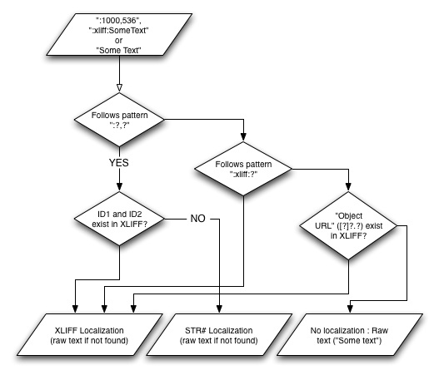

In 4D
The localization is now entirely sectoral. It means that localization is now local for a V4DDatabase and thus another V4Ddatabase cannot access the localization resources (XLIFF of RSR) of another V4DDatabase.

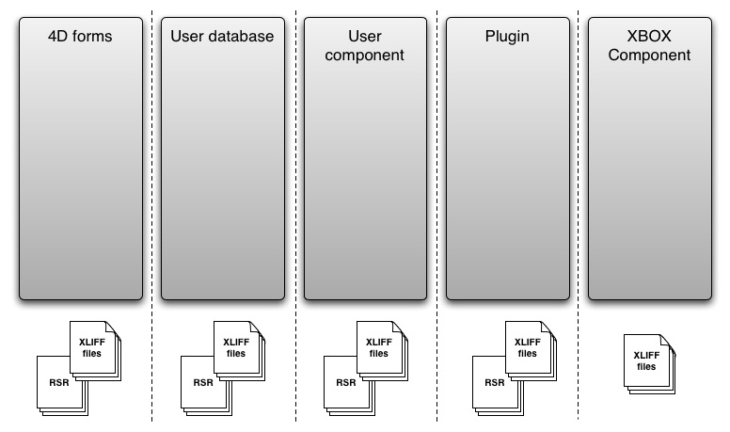

You have to be careful not to try using resources from another V4DDatabase! This used to work but won’t work anymore.

How to use it

With a V4DDatabase:
When you work inside or with a V4DDatabase, you need to ask the V4DlocalizationManager that is owned by your instance of V4DDatabase. This manager will try to find the localization if there is a need or a possibility in the old resources and in the XLIFF files.

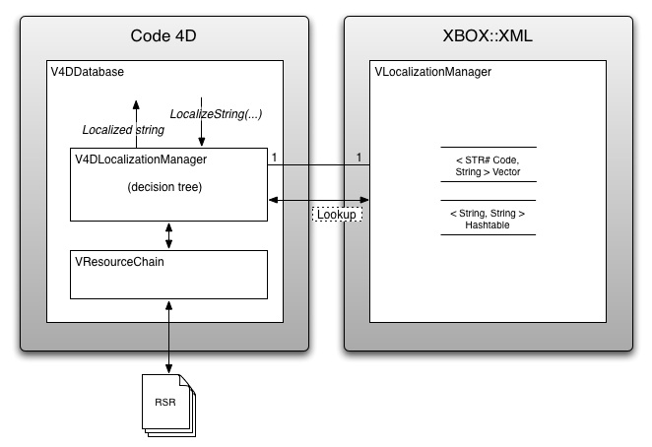

In a XBOX component
When you code a XBOX Component you may need to localize some things like error messages. You will be able to do that with XLIFF files. Remember that you need to create and use your local localization files for your own component.
You need to ask directly VLocalizationManager which is in the XML library of the new toolbox (XBOX). In order to do that, follow those steps :
- Create a local instance of VLocalizationManager with the language it will use.
- Give this instance XLIFF files to analyse. The recommended way is to use the method LoadDefaultLocalizationFolder that will use the language you gave at creation to find the appropriate folder.
- Ask your instance for localizations

Paths
Here are the standard paths for localization files. Those paths are followed by the language folders, like fr.lproj or French.lproj.

4D forms
- Mac: 4D_APPLICATION_FOLDER_ROOT/Contents/Resources/
- PC: 4D_APPLICATION_FOLDER_ROOT/Resources/

User database or component
- Mac: DATABASE_ROOT/Resources/ and 4D_APPLICATION_FOLDER_ROOT/Contents/Resources/LANGUE.lproj/CommonString.xlf
- PC: DATABASE_ROOT/Resources/ and 4D_APPLICATION_FOLDER_ROOT/Resources/LANGUE.lproj/CommonString.xlf

Plugin
- Mac: PLUGIN_ROOT/Contents/Resources/
- PC: PLUGIN_ROOT/Contents/Resources/

4D Components :
- Mac: COMPONENT_ROOT/Contents/Resources/
- PC: COMPONENT_ROOT/Contents/Resources/

